**Position: Clinical Trainer**

**Location: North, Midlands & South**

**Central office: Southside Building, 31 Hurst Street, Birmingham, West Midlands, B5 4BD**

**Reporting to: Group Training Manager for Health Care**

**Salary: £41,200 (including car allowance)**

# **Job Purpose:**

The post holder will be responsible for the delivery of a range of clinical skills training across both the health and social care division of the company. Training will be for both registered professionals (nurses, OT’s, etc.) and non-registered staff, such as support workers. Training will include subjects such as venepuncture, insulin administration, Peg and Naso-gastric feeding, administration of buccal midazolam, managing continence and wound care.

* To deliver a wide range of clinical skills training appropriate to the role being trained and in accordance with identified service requirements.
* Deliver training using a range of teaching methods that encourage participation and development of skills and knowledge.
* To deliver training in a range of formats, including virtual workshops where appropriate.
* To assess the skills and knowledge relevant to course content.
* Provide structured feedback to those that need additional coaching and have not met the required competency level within a classroom setting.
* Work cohesively and effectively with the wider members of the Learning and Development team.
* To liaise with the Resuscitation Lead and wider Learning and Development team to organise and plan the delivery of courses.
* To work with the Head of Learning and Development, Clinical Leads and Training Managers to promote a cohesive learning and development culture within Cygnet Health Care.
* To maintain current subject knowledge and competence, in line with Cygnet Health Care requirements.
* To maintain your own continuous professional development (CPD) and maintain a Trainer portfolio in addition to any professional portfolio, such as revalidation.
* To ensure the health, safety and wellbeing of all those attending training.
* To respect and adhere to the security arrangements if training at a Cygnet site.
* Manage the classroom environment to ensure equal and safe participation.
* To follow safeguarding processes and report to a service manager any reportable concerns brought to your attention during training
* Ensure any equipment used for training is available ‘on demand’, is clean and fit for purpose and that any damage or faults are identified and reported.
* Accurate completion and prompt submission of course administration using relevant systems.
* To work on ad hoc projects as directed by the Head of Learning and Development.
* Perform any other duties commensurate with these responsibilities, skills and qualifications of the post holder.

**Personal Specification:**

|  |  |  |
| --- | --- | --- |
| **Skills Required** | **Essential / Desirable** | **Demonstration** |
| Registered Health Professional (NMC/HCPC). | E | Application / Recruitment |
| Level 3 Award (or above) in Education & Training or obtained within 6 months of employment. | D | Application / Interview |
| Relevant experience in a training/teaching environment. | E | Application / Interview |
| Previous experience in clinical education or training. | E | Application / Interview |
| General knowledge of training and development ideally within the health or social care sectors. | E | Application / Interview |
| Excellent interpersonal skills with ability to communicate effectively at all levels. | E | Application / Interview |
| Team player with sense of humour. | E | Application / Interview |
| Experience of using office IT packages. | E | Application / Interview |
| Flexible approach to work with ability to commit to evenings and weekends. | E | Application / Interview |
| Willing to be flexible to travel and deliver training in different formats. | E | Application / Interview |
| Experience of learner centred learning. | D | Application / Interview |
| Understanding of Cygnet Health Care training procedures and protocols. | D | Application / Interview |

**What you will influence**

* Outstanding training standards through training delivery.
* Enabling others to achieve their goals and ambitions.
* Engagement and motivation throughout sessions that will continue after the session in other Cygnet Health Care activities.

**Benefits**

**A rewarding career that comes with great benefits**

There are plenty of benefits working at Cygnet, including the expected, like competitive pay and pension, out of pocket expenses, too five weeks annual leave and bank holidays. But we’ll also give you the discounts and rewards you deserve.

For more information, visit:

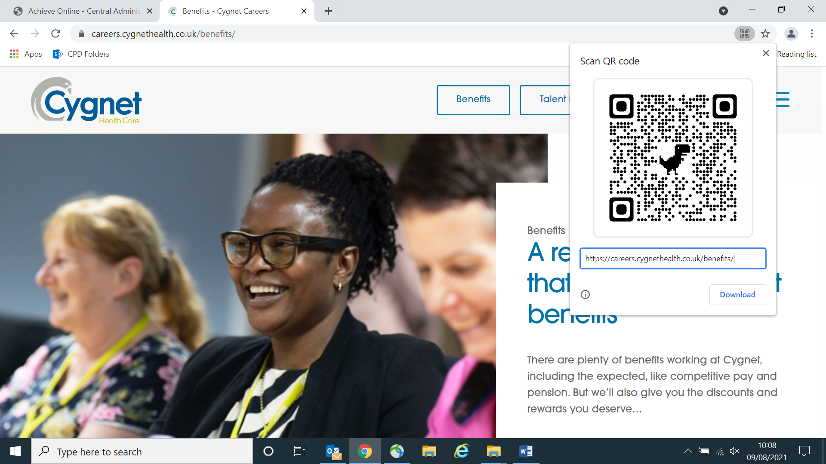

<https://careers.cygnethealth.co.uk/benefits>

**Our Values, what makes Cygnet**

Our core values are the principles under which we operate on a daily basis; how we represent the company; how we relate to each other; how we support those within our care should be reflective of these core values.

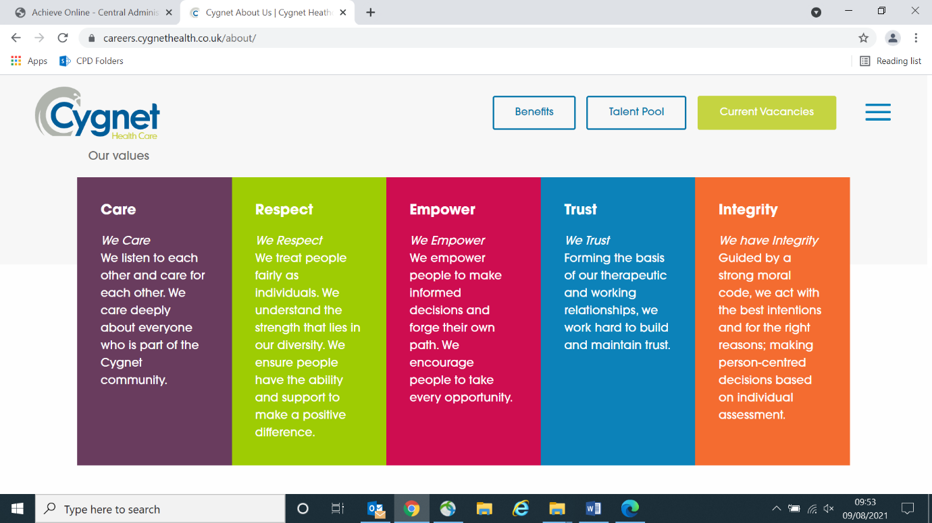

Find out more by visiting:

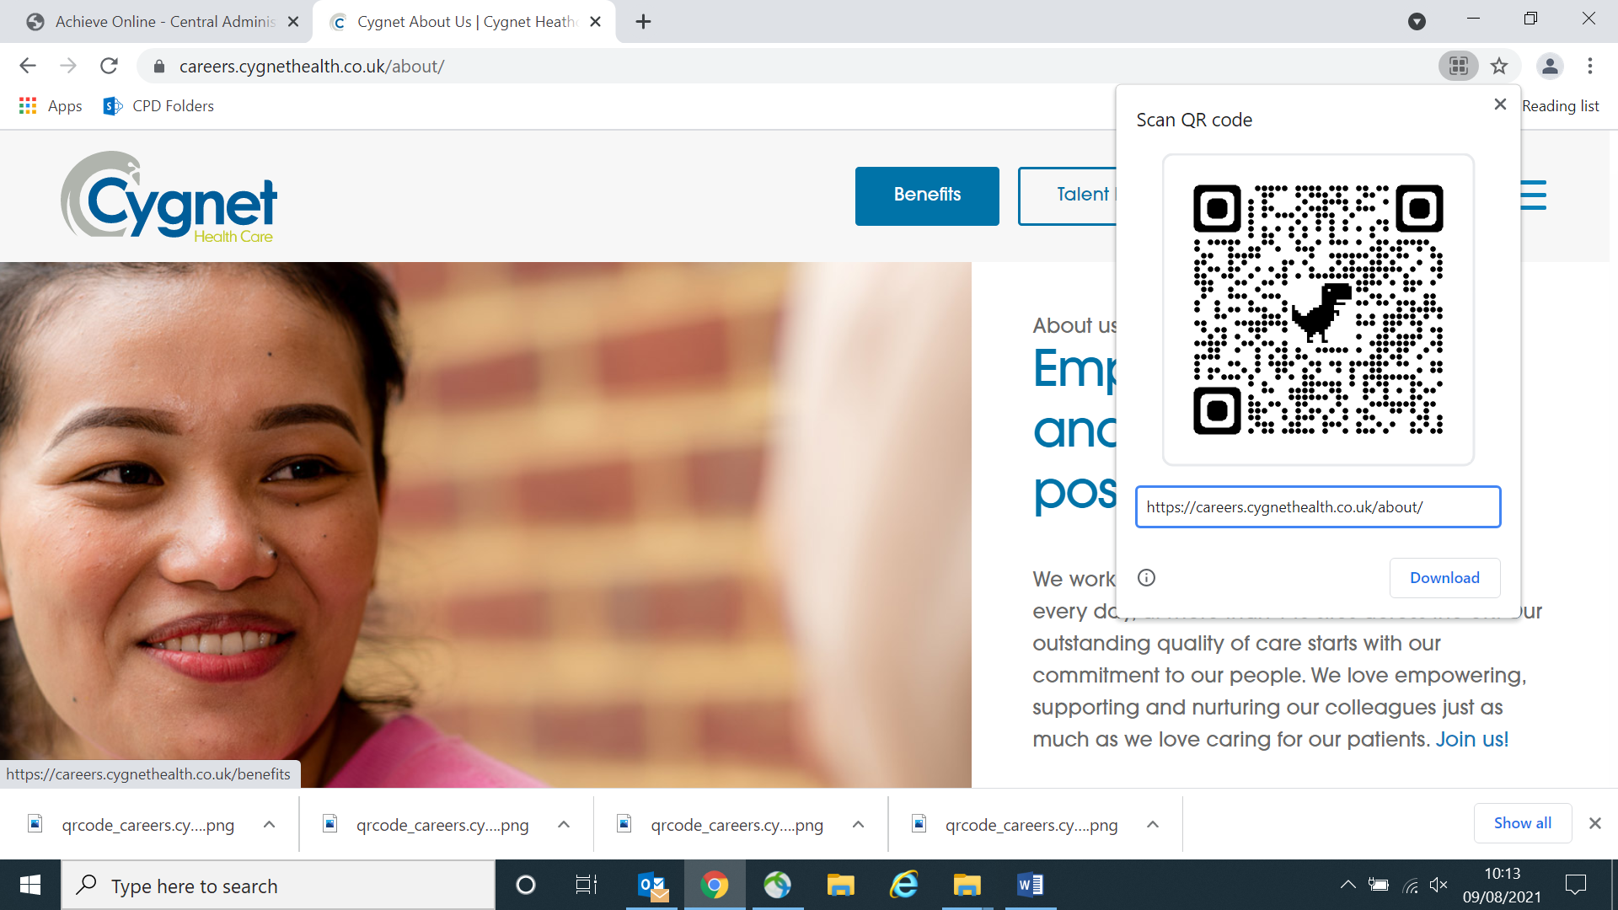

<https://careers.cygnethealth.co.uk/about>